**How to install and Connect to oracle DB**

**Steps:**

**1)Download appropriate sql developer for your computer**

<https://www.oracle.com/tools/downloads/sqldev-v192-downloads.html>

( you may have to create an online account to download it )

**2)Once downloaded, install the application**

**3)Once installed open the Application**

You will not see any connections

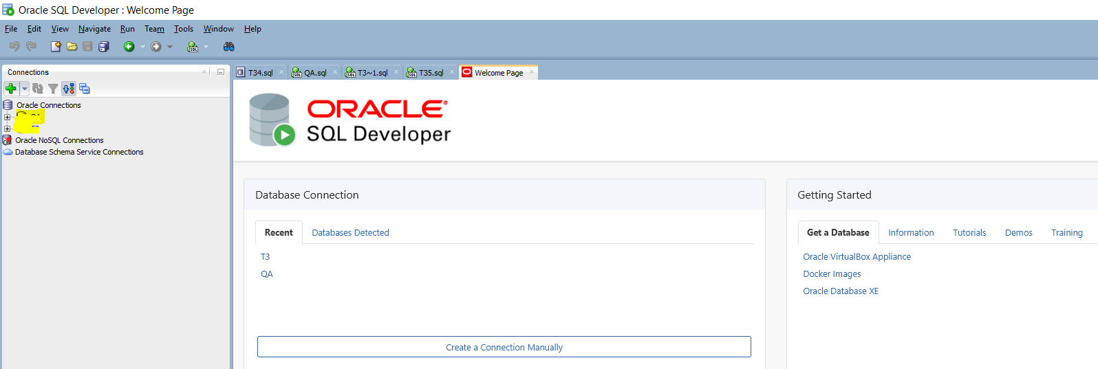

If you do not see the connections pane on left:

Click on view->connections

**4)Click on + button to add a connection**

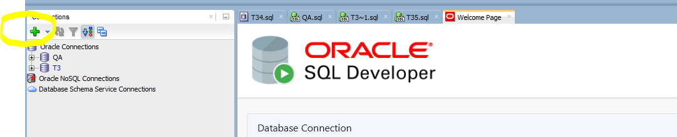

**5) Input the following information**

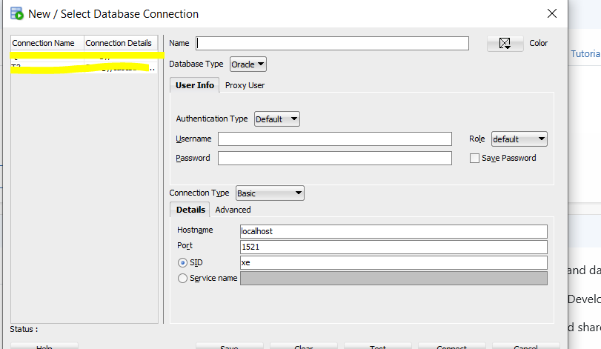

Name:sampledb

Username:admin

PW:Transfotech0312!

Hostname:oracledb.cv74nx62erny.us-east-1.rds.amazonaws.com

Port:1521

SID:oracledb

**6)Click test, once successful..click save and connect. You can expand the connection and then expand the tables and you should see a list of tables**

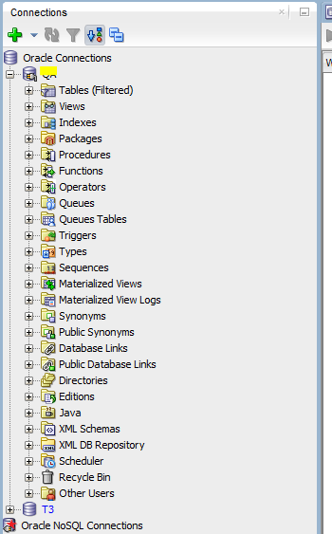

Your table structure should be as follows:

